IE 575 Final Exam

Eric Smith

2025-08-04

Part 1, Task 1.1 Explore the Retail Dataset
# Load data
data <- read_excel("Online_Retail.xlsx")

head(data)
## # A tibble: 6 × 8
## InvoiceNo StockCode Description Quantity InvoiceDate UnitPrice
## <chr> <chr> <chr> <dbl> <dttm> <dbl>
## 1 536365 85123A WHITE HANGING HEAR… 6 2010-12-01 08:26:00 2.55
## 2 536365 71053 WHITE METAL LANTERN 6 2010-12-01 08:26:00 3.39
## 3 536365 84406B CREAM CUPID HEARTS… 8 2010-12-01 08:26:00 2.75
## 4 536365 84029G KNITTED UNION FLAG… 6 2010-12-01 08:26:00 3.39
## 5 536365 84029E RED WOOLLY HOTTIE … 6 2010-12-01 08:26:00 3.39
## 6 536365 22752 SET 7 BABUSHKA NES… 2 2010-12-01 08:26:00 7.65
## # ℹ 2 more variables: CustomerID <dbl>, Country <chr>
summary(data)
## InvoiceNo StockCode Description Quantity
## Length:541909 Length:541909 Length:541909 Min. :-80995.000
## Class :character Class :character Class :character 1st Qu.: 1.000
## Mode :character Mode :character Mode :character Median : 3.000
## Mean : 9.552
## 3rd Qu.: 10.000
## Max. : 80995.000
##
## InvoiceDate UnitPrice CustomerID
## Min. :2010-12-01 08:26:00 Min. :-11062.060 Min. :12346
## 1st Qu.:2011-03-28 11:34:00 1st Qu.: 1.250 1st Qu.:13953
## Median :2011-07-19 17:17:00 Median : 2.080 Median :15152
## Mean :2011-07-04 13:34:57 Mean : 4.611 Mean :15288
## 3rd Qu.:2011-10-19 11:27:00 3rd Qu.: 4.130 3rd Qu.:16791
## Max. :2011-12-09 12:50:00 Max. : 38970.000 Max. :18287
## NA's :135080
## Country
## Length:541909
## Class :character
## Mode :character
##
##
##
##
# Count missing values before removal
missing_values_before <- colSums(is.na(data))
print(missing_values_before)
## InvoiceNo StockCode Description Quantity InvoiceDate UnitPrice
## 0 0 1454 0 0 0
## CustomerID Country
## 135080 0
# Remove rows with missing values
data <- na.omit(data)
# Remove rows with missing values -- For the sake of argument, we may only want to track our known customers
data <- na.omit(data)
# Check for duplicate values
duplicate_values <- data[duplicated(data), ]
if (nrow(duplicate_values) > 0) {
print("Count of duplicate values found:")
print(nrow(duplicate_values))
} else {
print("No duplicate values found.")
}
## [1] "Count of duplicate values found:"
## [1] 5225
# Convert InvoiceDate to POSIXct
data$InvoiceDate <- as.POSIXct(data$InvoiceDate, format = "%Y-%m-%d %H:%M:%S")
# === Extract date and time components ===
data$date_only <- as.Date(data$InvoiceDate)
data$hour_only <- hour(data$InvoiceDate)

# Optional: create a "total value" column for analysis
data <- data %>%
mutate(TotalValue = Quantity * UnitPrice)

# === How many days are in the dataset? ===
unique_days <- unique(data$date_only)
num_days <- length(unique_days)
cat("Number of unique days in dataset:", num_days, "\n")
## Number of unique days in dataset: 305
# === How many records per day? ===
records_per_day <- table(data$date_only)
records_per_day_vec <- as.numeric(records_per_day)

# Summary statistics
cat("Summary of Records per Day:\n")
## Summary of Records per Day:
summary(records_per_day_vec)
## Min. 1st Qu. Median Mean 3rd Qu. Max.
## 221 923 1186 1334 1561 3434
records_df <- data.frame(Date = as.Date(names(records_per_day)), Count = as.numeric(records_per_day))

ggplot(records_df, aes(x = Count)) +
geom_histogram(binwidth = 50, fill = "steelblue", color = "white") +
labs(title = "Distribution of Records per Day", x = "Record Count", y = "Frequency") +
theme_minimal()
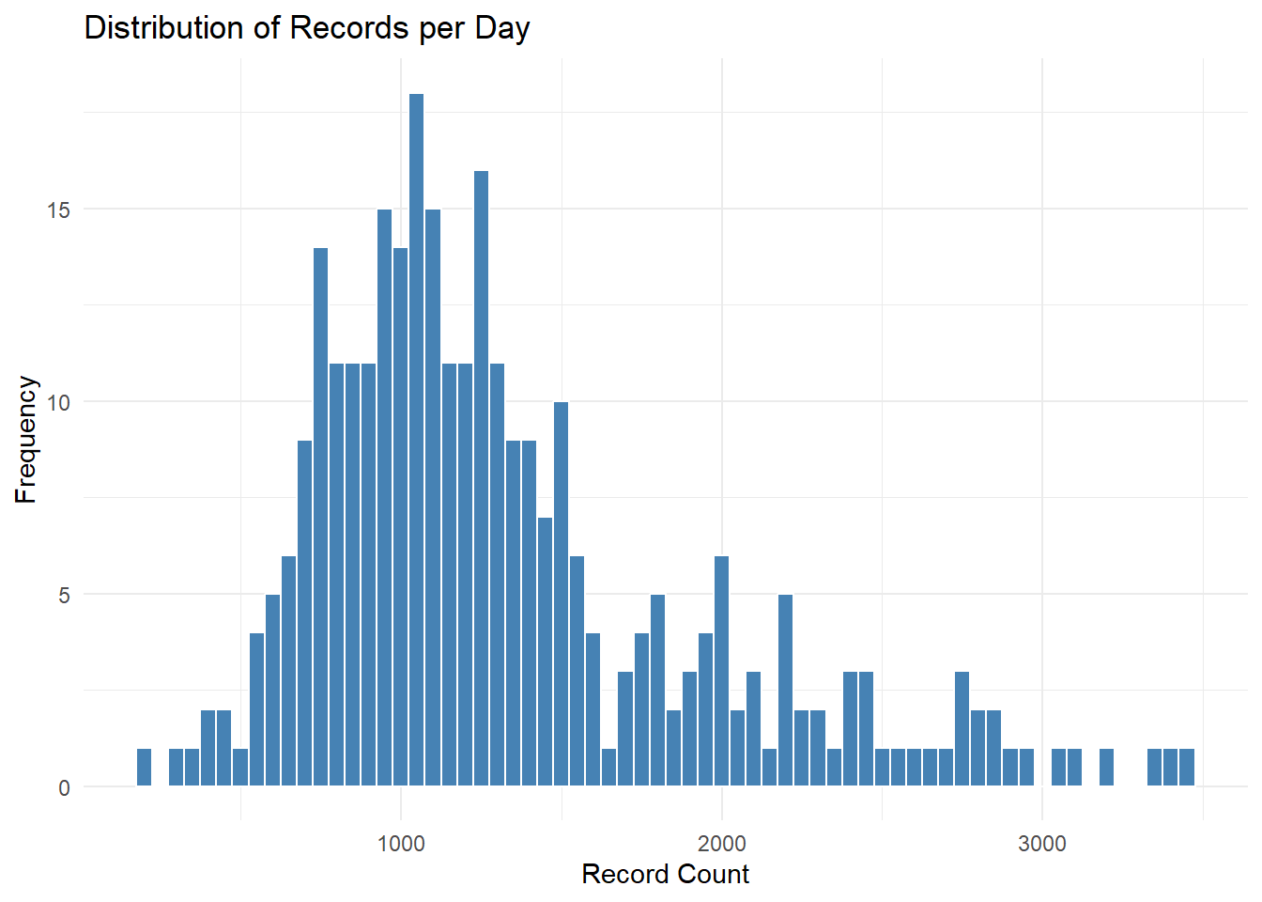
Fig. 1: Distribution of Records per Day
Data Exploration
The dataset contained 541,909 transactions from Dec, 2010 to Dec. 2011 with eight variables. Summary showed extreme Quantity (min = -80,995, max = 80,995) and UnitPrice (min = -11,062.06, max = 38,970) values. Missing data checks found 1,454 missing Description entries and 135,080 missing CustomerID values. All 135,080 incomplete rows were removed via na.omit() supposing that we only wanted to analyze known customers. Duplicates were checked but not removed, and derived fields (date_only, hour_only, TotalValue) were created.
Daily aggregation revealed 305 unique days, with transactions/day ranging from 221 to 3,434 (median = 1,186).
Key Observations:
- 135,080 rows removed due to missing customer ID values.
- Quantity and UnitPrice show extreme outliers.
- Noticable daily variation looks to support a time series formulation.

Part 1, Task 1.2 Aggregate Daily Sales
data <- data %>%
mutate(date_only = as.Date(InvoiceDate),
TotalValue = Quantity * UnitPrice)

# Daily aggregation
daily_sales <- data %>%
group_by(date_only) %>%
summarise(Total_Sales = sum(TotalValue, na.rm = TRUE))

# Complete daily sequence
full_dates <- data.frame(date_only = seq(min(daily_sales$date_only), max(daily_sales$date_only), by = “day”))
daily_sales_complete <- full_dates %>%
left_join(daily_sales, by = “date_only”) %>%
mutate(Total_Sales = replace_na(Total_Sales, 0))

# Cap at 99th percentile
threshold <- quantile(daily_sales_complete$Total_Sales, 0.99)
daily_sales_complete <- daily_sales_complete %>%
mutate(Capped_Sales = ifelse(Total_Sales > threshold, threshold, Total_Sales))
daily_sales_complete <- daily_sales_complete %>%
arrange(date_only) %>%
mutate(Smoothed_Sales = rollmean(Capped_Sales, k = 7, fill = NA, align = “right”))

ggplot(daily_sales_complete, aes(x = date_only, y = Smoothed_Sales)) +
geom_line(color = “steelblue”, size = 1) +
labs(title = “7-Day Smoothed Capped Daily Sales”,
x = “Date”, y = “Sales (pounds) — 7-Day Avg”) +
scale_x_date(date_labels = “%b %Y”, date_breaks = “1 month”) +
theme_minimal() +
theme(axis.text.x = element_text(angle = 45, hjust = 1))
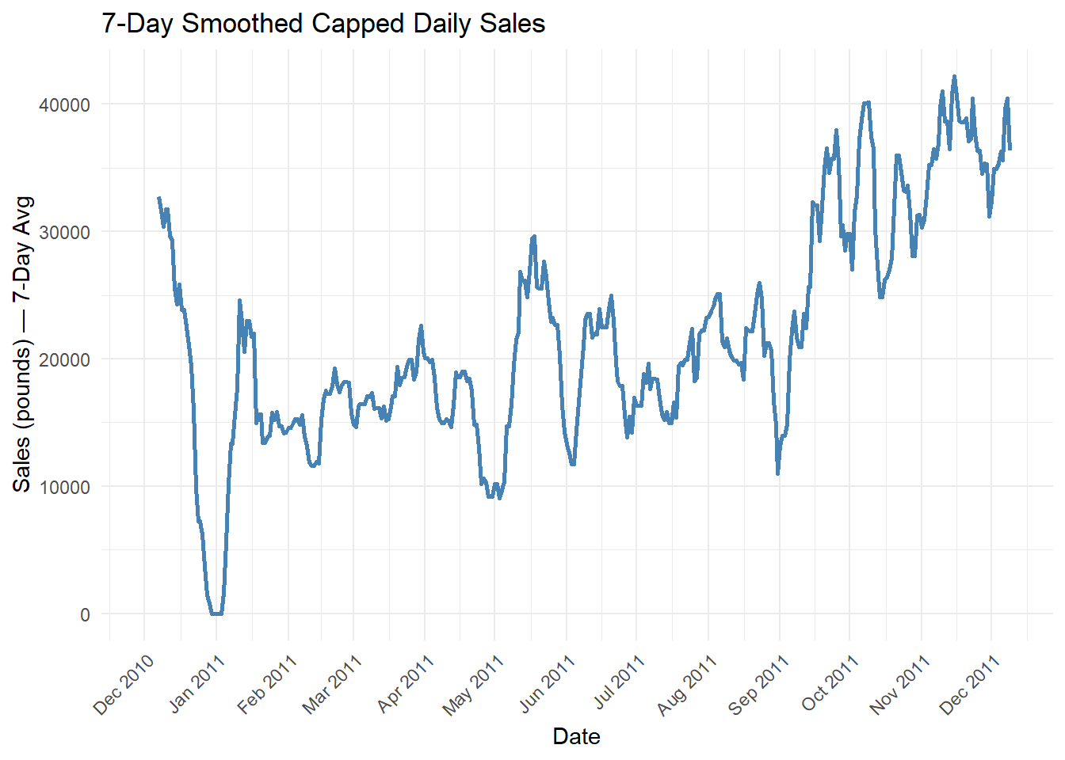
Fig. 2: 7-Day Smoothed Capped Daily Sales

Aggregation Choice
Sales were aggregated to the daily level to capture short-term variability, looking at one premise that the business owner may want to anticipate expected daily sales, although this could be done for weekly sales. While weekly aggregation could smooth volatility, daily data may be valuable for exploring daily expectations. The 7-day smoothed series shows short-term rises and falls, with an overall upward movement through 2011.

Part 1, Task 1.3 Raw Time Series Decomposition
ts_raw <- ts(daily_sales_complete$Capped_Sales, frequency = 7)
decomp <- stl(ts_raw, s.window = “periodic”)
plot(decomp)
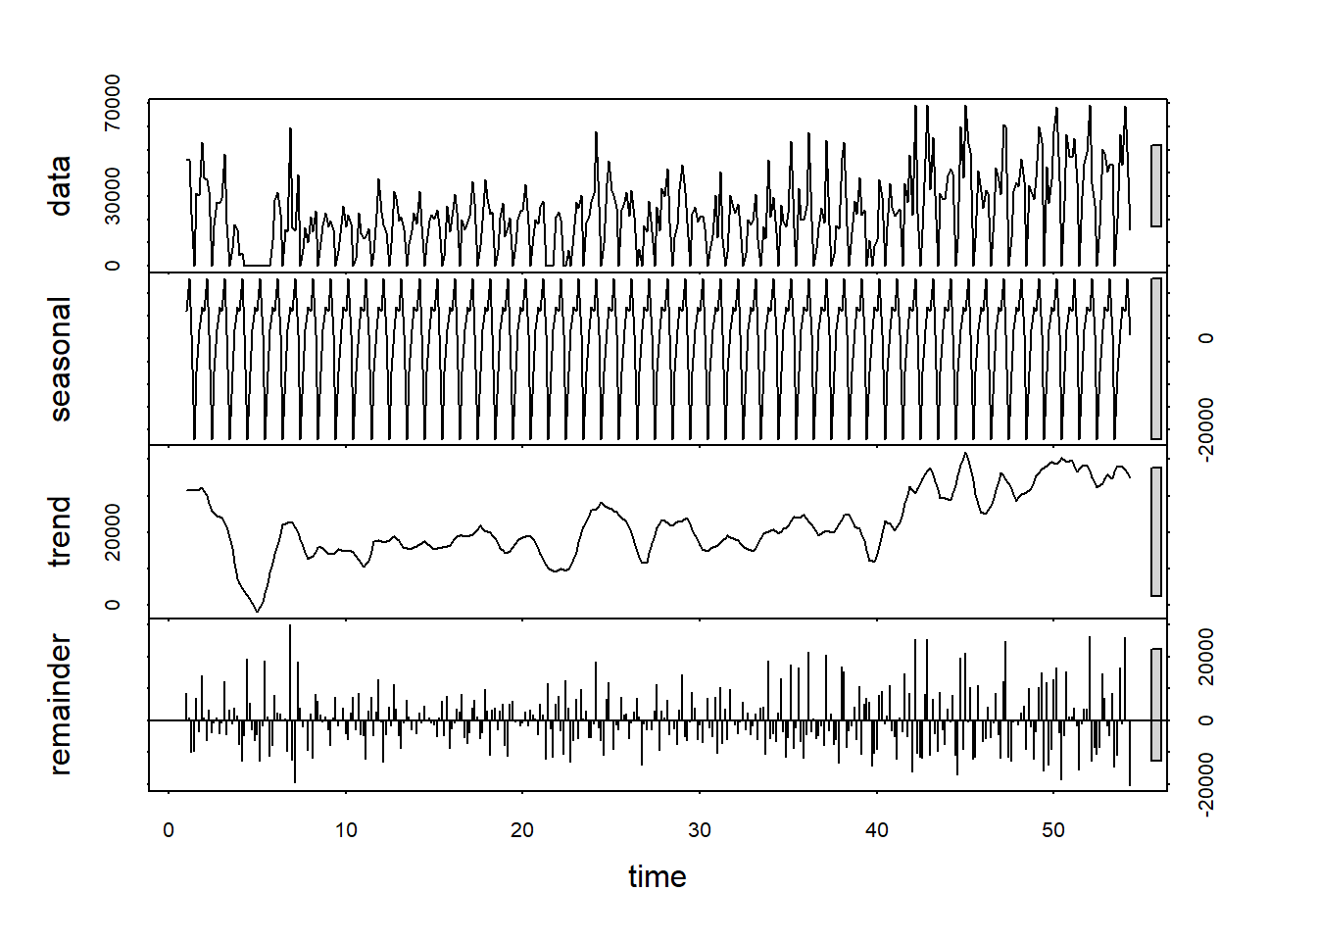
Fig. 3: STL Decomposition of Daily Sales

deseasonal <- seasadj(decomp)
sales_diff <- diff(deseasonal)
adf.test(sales_diff)
##
## Augmented Dickey-Fuller Test
##
## data: sales_diff
## Dickey-Fuller = -9.4375, Lag order = 7, p-value = 0.01
## alternative hypothesis: stationary
par(mfrow=c(2,1))
acf(sales_diff, main = “ACF of Differenced Series”)
pacf(sales_diff, main = “PACF of Differenced Series”)
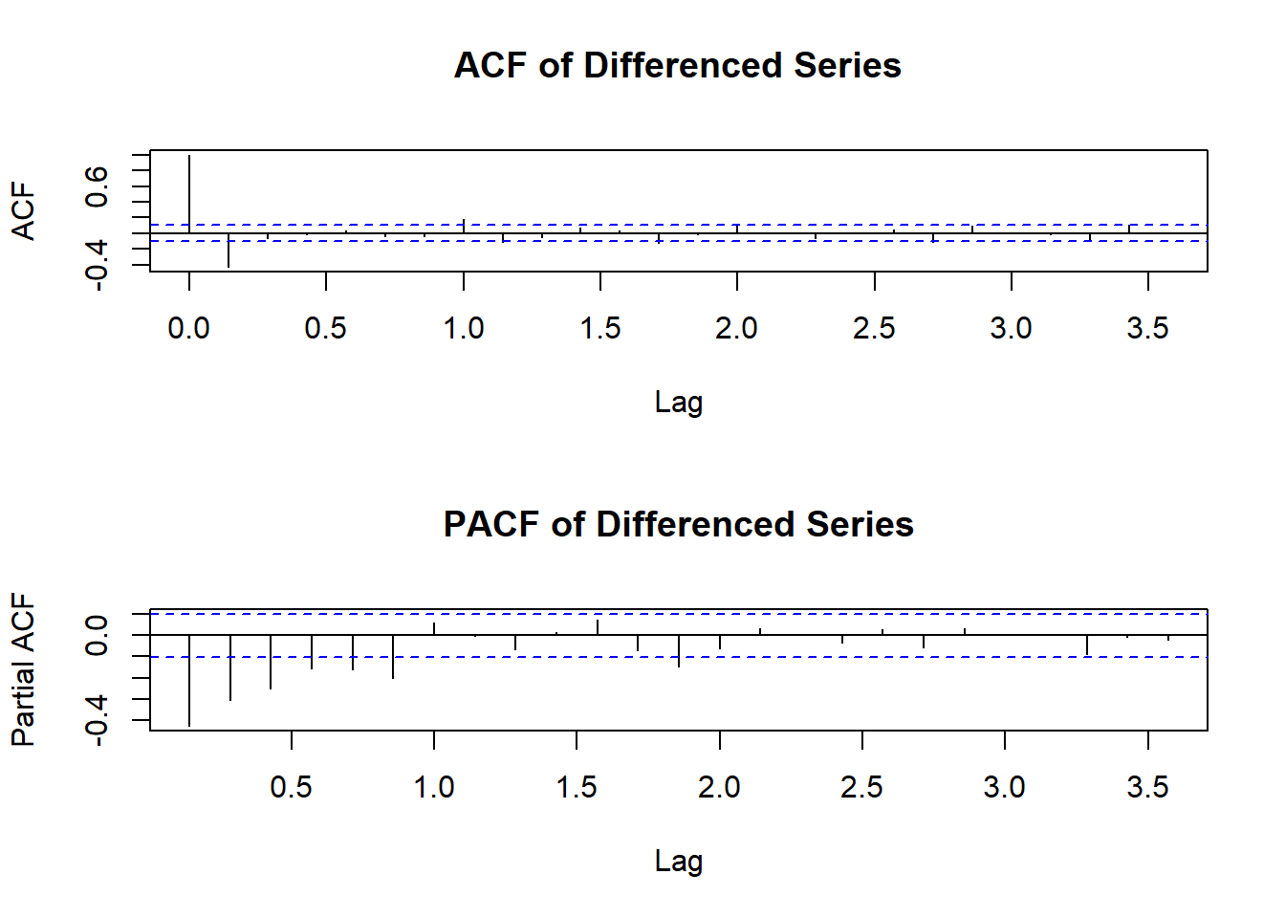
Fig. 4: ACF and PACF of Differenced Series

Decomposition, Stationarity, ACF an PACF
The decomposition reveals strong recurring weekly patterns, confirmed by the clear periodic spikes in the seasonal component. The trend shows a gradual increase in sales over time with short-term fluctuations, while the remainder is relatively small but irregular. The ACF and PACF plots show that the influence of past data drops sharply after just one lag. This is statistically supported by the Augmented Dickey-Fuller test (p-value = 0.01), telling us that the data is ready for ARIMA modeling.

Part 1, Task 1.4 Outlier Detection and Replacement
# --- Outlier detection & plotting (hardened against missing `types`) ---

y_ts <- ts_raw
out <- forecast::tsoutliers(y_ts) # $index, $replacements, (sometimes) $types

# Align dates safely to the series length
dates_ts <- tail(daily_sales_complete$date_only, length(y_ts))

# Always-initialized vectors
idx_all <- seq_along(y_ts)
is_out <- rep(FALSE, length(y_ts))
out_type <- rep(NA_character_, length(y_ts))

if (length(out$index) > 0) {
# If `types` is missing or length 0, create a generic label vector of same length as indices
types_safe <- if (!is.null(out$types) && length(out$types) == length(out$index)) {
out$types
} else {
rep(“outlier”, length(out$index))
}

is_out[out$index] <- TRUE
out_type[out$index] <- types_safe
}

df_out <- tibble(
idx = idx_all,
Date = dates_ts,
Value = as.numeric(y_ts),
is_out = is_out,
out_type = out_type
)

# Plot
p <- ggplot(df_out, aes(Date, Value)) +
geom_line(linewidth = 0.7, color = “steelblue”) +
geom_point(data = dplyr::filter(df_out, is_out), color = “red”, size = 2) +
labs(title = “Daily Sales with Detected Outliers Highlighted”,
x = NULL, y = “Capped Sales (pounds)”) +
theme_minimal()

# Optional labels (uses base geom_text to avoid extra deps)
if (any(is_out)) {
p <- p + geom_text(
data = dplyr::filter(df_out, is_out),
aes(label = out_type),
vjust = -0.8, size = 3
)
}
print(p)
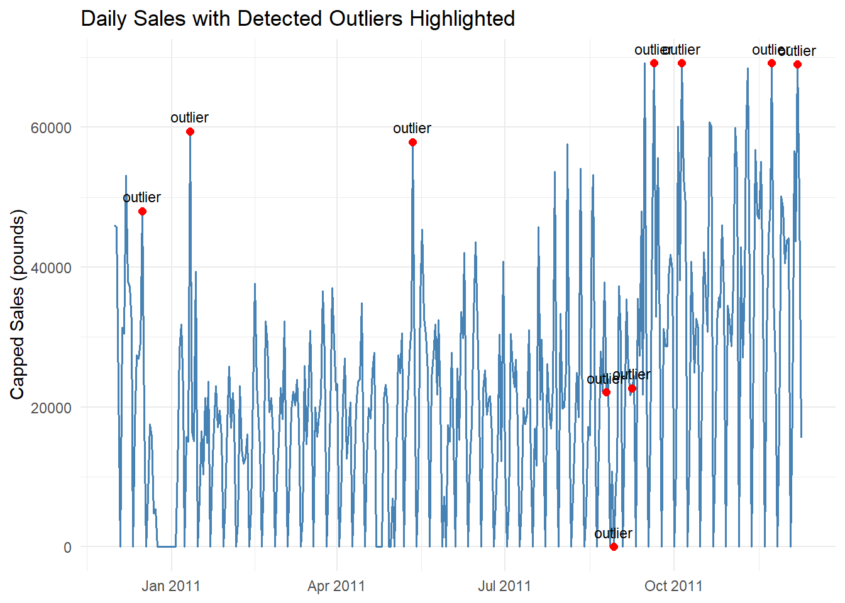
Fig. 5: Daily Sales with Detected Outliers Highlighted
# Clean only flagged points
y_ts_clean <- y_ts
if (length(out$index) > 0) {
y_ts_clean[out$index] <- out$replacements
}
Detecting and Removing Outliers
The tsoutliers function detected 10 significant anomalies in the daily sales series, including both unusually high spikes and a zero-sales day. Each was flagged as an “outlier” and replaced with an estimated value based on the surrounding data to reduce distortion in model fitting. You can see the extreme values in the charting, and we’ll be removing the outliers for our models.

Part 1, Task 2.1 Creating ARIMA Models, Forecasting and Comparision
# Original series (with outliers still present)
y_ts_orig <- y_ts

# 1) Manual model on CLEANED series (deseasonalize via STL, then ARIMA(1,1,1) on seasadj)
decomp_clean <- stl(y_ts_clean, s.window = “periodic”)
deseasonal_clean <- seasadj(decomp_clean)

model_manual_clean <- forecast::Arima(deseasonal_clean, order = c(1,1,1))

# Build a seasonal index to add back for h-step forecasts
# NOTE: this aligns the next h seasonal components to the day *after* the last observation.
H <- 10
freq <- frequency(y_ts_clean) # expected 7 for daily with weekly seasonality
seasonal_pattern <- tapply(decomp_clean$time.series[, “seasonal”], cycle(y_ts_clean), mean)
phase_next <- (cycle(y_ts_clean)[length(y_ts_clean)] %% freq) + 1
seasonal_future <- seasonal_pattern[((phase_next – 1) + 0h – 1)) %% freq + 1]

# 2) Auto models (original vs cleaned) for comparison
model_auto_orig <- forecast::auto.arima(y_ts_orig, stepwise = FALSE, approximation = FALSE)
model_auto_clean <- forecast::auto.arima(y_ts_clean, stepwise = FALSE, approximation = FALSE)
# --- Diagnostics ---

# Helper to get Ljung–Box p-value with a reasonable lag
.lb_pval <- function(model, lag_max = 15) {
r <- residuals(model)
n <- length(r)
lag <- min(lag_max, n - 1)
# fitdf: nonseasonal p+q + seasonal P+Q if available
fitdf <- tryCatch({
arma <- model$arma
if (length(arma) >= 4) sum(pmax(0, arma[c(1,2,3,4)])) else 0
}, error = function(e) 0)
tryCatch(Box.test(r, lag = lag, type = "Ljung-Box", fitdf = fitdf)$p.value,
error = function(e) NA_real_)
}

# Summarize ACF/PACF without plotting
.summarize_resid <- function(model, label, lag_max = 15) {
r <- as.numeric(residuals(model))
n <- length(r)
se <- 1 / sqrt(n)

acf_vals <- tryCatch(acf(r, plot = FALSE, lag.max = lag_max)$acf[-1], error = function(e) rep(NA_real_, lag_max))
pacf_vals <- tryCatch(pacf(r, plot = FALSE, lag.max = lag_max)$acf, error = function(e) rep(NA_real_, lag_max))

data.frame(
Model = label,
AICc = suppressWarnings(if (!is.null(model$aicc)) model$aicc else AIC(model)),
BIC = tryCatch(BIC(model), error = function(e) NA_real_),
ResidSD = sqrt(model$sigma2),
LB_p = .lb_pval(model, lag_max = lag_max),
MaxAbsACF = max(abs(acf_vals), na.rm = TRUE),
MaxAbsPACF = max(abs(pacf_vals), na.rm = TRUE),
SigACF_Count = sum(abs(acf_vals) > 1.96 * se, na.rm = TRUE),
SigPACF_Count = sum(abs(pacf_vals) > 1.96 * se, na.rm = TRUE),
check.names = FALSE
)
}

diag_table <- bind_rows(
.summarize_resid(model_manual_clean, "Manual ARIMA (Cleaned, deseasonal)", lag_max = 15),
.summarize_resid(model_auto_orig, "Auto ARIMA (Original)", lag_max = 15),
.summarize_resid(model_auto_clean, "Auto ARIMA (Cleaned)", lag_max = 15)
) %>%
mutate(
across(c(AICc, BIC, ResidSD, LB_p, MaxAbsACF, MaxAbsPACF), ~round(., 3))
)

kable(diag_table, caption = "Table 1. Residual Diagnostics (ACF/PACF & Ljung–Box, lag ≤ 15)")
Table 1. Residual Diagnostics (ACF/PACF & Ljung–Box, lag ≤ 15)
Model | AICc | BIC | ResidSD | LB_p | Max  AbsA  CF | Max  Abs  PACF | Sig  ACF_Count | Sig  PACF_Count
Manual ARIMA (Cleaned, deseasonal) | 7891.376 | 7903.076 | 9436.046 | 0.000 | 0.291 | 0.275 | 6 | 3
Auto ARIMA (Original) | 7839.454 | 7854.965 | 10334.149 | 0.256 | 0.098 | 0.104 | 0 | 1
Auto ARIMA (Cleaned) | 7738.015 | 7757.376 | 9003.747 | 0.720 | 0.066 | 0.066 | 0 | 0
Model Diagnostics
Cleaning the series before fitting improved both model fit and residual diagnostics for the automatic and manual ARIMA models. The cleaned Auto ARIMA performed best, with the lowest AICc and BIC, smallest residual variance, and no significant autocorrelation—indicating it captured the time series structure well. The manual ARIMA left notable residual autocorrelation, suggesting it underfit the data..
# --- Forecasts & plots (original vs cleaned) ---

# Manual (cleaned): forecast deseasonalized model, then add seasonality back
fc_manual_deseason <- forecast::forecast(model_manual_clean, h = h)
fc_manual_clean <- fc_manual_deseason
fc_manual_clean$mean <- fc_manual_deseason$mean + seasonal_future
fc_manual_clean$lower <- fc_manual_deseason$lower + matrix(seasonal_future, nrow = h, ncol = ncol(fc_manual_deseason$lower), byrow = FALSE)
fc_manual_clean$upper <- fc_manual_deseason$upper + matrix(seasonal_future, nrow = h, ncol = ncol(fc_manual_deseason$upper), byrow = FALSE)

# Auto (original vs cleaned)
fc_auto_orig <- forecast::forecast(model_auto_orig, h = h)
fc_auto_clean <- forecast::forecast(model_auto_clean, h = h)

# Plots stacked vertically with compact height
par(mfrow = c(3, 1), # 3 rows, 1 column
mar = c(3, 4, 3, 2)) # smaller margins: bottom, left, top, right

plot(fc_manual_clean, main = "Manual ARIMA Forecast on CLEANED Series (seasonality added back)")
plot(fc_auto_orig, main = "Auto ARIMA Forecast (ORIGINAL series)")
plot(fc_auto_clean, main = "Auto ARIMA Forecast (CLEANED series)")
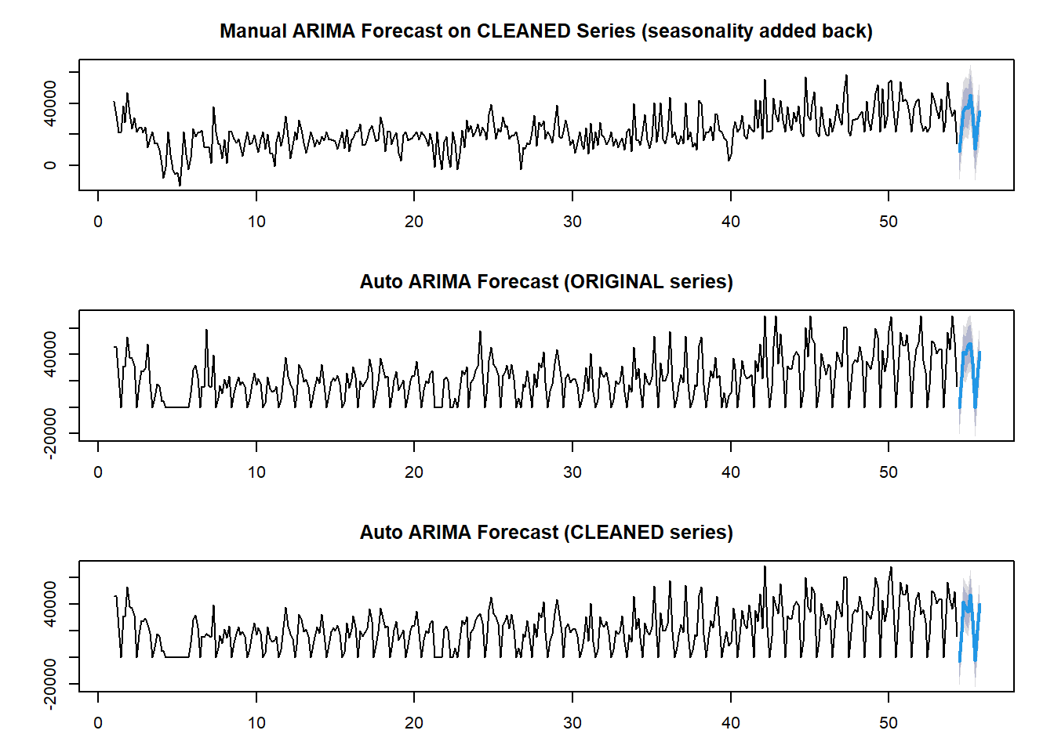
Fig. 6: Forecasts from Different ARIMA Models
# --- 2.2 Forecast comparison (manual-clean vs auto-clean) ---
forecast_dates <- seq(max(daily_sales_complete$date_only) + 1, by = "day", length.out = h)

df_auto_clean <- data.frame(
Date = forecast_dates,
Forecast = as.numeric(fc_auto_clean$mean),
Lower = as.numeric(fc_auto_clean$lower[, 2]),
Upper = as.numeric(fc_auto_clean$upper[, 2]),
Model = "Auto ARIMA (Cleaned)"
)

df_manual_clean <- data.frame(
Date = forecast_dates,
Forecast = as.numeric(fc_manual_clean$mean),
Lower = as.numeric(fc_manual_clean$lower[, 2]),
Upper = as.numeric(fc_manual_clean$upper[, 2]),
Model = "Manual ARIMA (Cleaned, deseasonal->reseas.)"
)

combined_forecasts_clean <- dplyr::bind_rows(df_auto_clean, df_manual_clean)

ggplot(combined_forecasts_clean, aes(x = Date, y = Forecast, color = Model, fill = Model)) +
geom_line(size = 1.2) +
geom_ribbon(aes(ymin = Lower, ymax = Upper), alpha = 0.2, color = NA) +
labs(
title = "10-Day Forecasts on CLEANED Series: Manual vs Auto",
x = "Date", y = "Predicted Daily Sales (pounds)"
) +
theme_minimal()
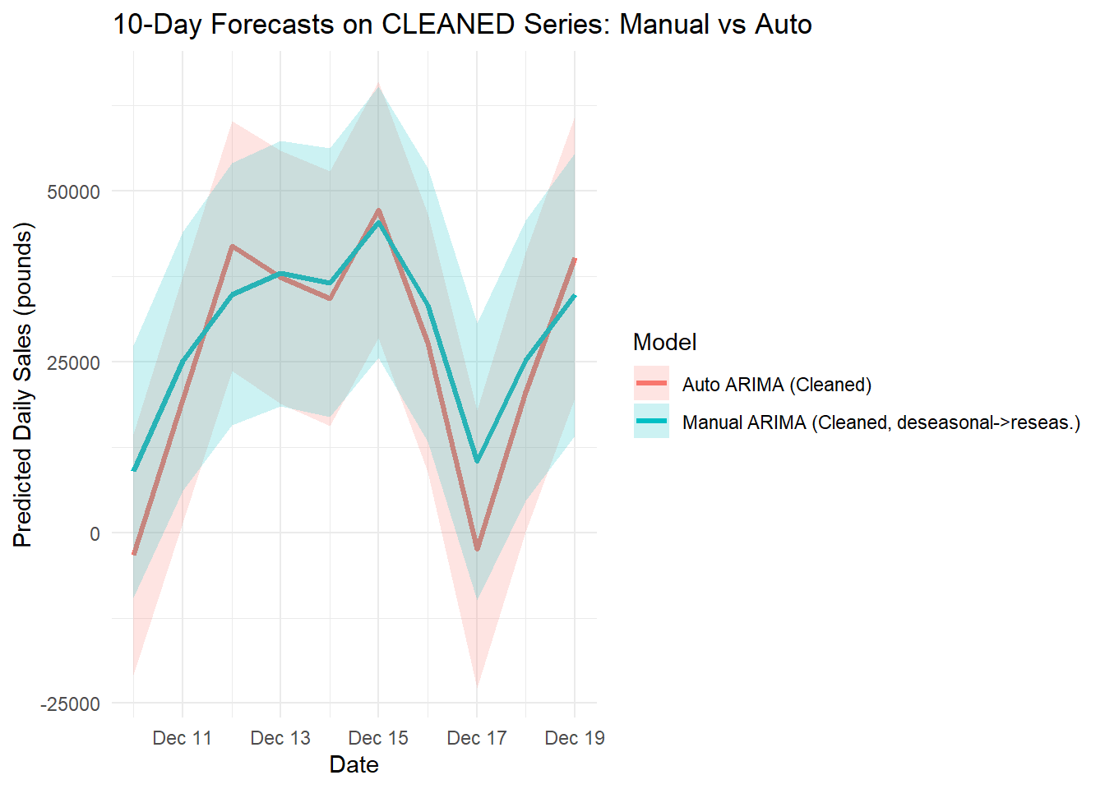
Fig. 7: 10-Day Forecasts on CLEANED Series: Manual vs Auto
get_train_metrics <- function(fc, label) {
m <- as.data.frame(forecast::accuracy(fc))
m <- m[1, , drop = FALSE] # row 1 = in-sample (training) metrics
m$Model <- label
m
}

fcs <- list()
if (exists("fc_auto_orig")) fcs[["Auto ARIMA (Original)"]] <- fc_auto_orig
if (exists("fc_auto_clean")) fcs[["Auto ARIMA (Outliers Removed)"]] <- fc_auto_clean
if (exists("fc_manual_clean")) fcs[["Manual ARIMA (Outliers Removed)"]] <- fc_manual_clean

if (length(fcs) == 0) {
stop("No forecast objects found. Ensure the forecast chunk ran.")
}

comparison <- do.call(
rbind,
lapply(names(fcs), function(lbl) get_train_metrics(fcs[[lbl]], lbl))
) %>%
select(Model, ME, RMSE, MAE, MASE)

kable(comparison, caption = "Table 2. Model Comparison (Training Set)")
Table 2. Model Comparison (Training Set)
 | Model | ME | RMSE | MAE | MASE
Training set | Auto ARIMA (Original) | 250.93011 | 10195.056 | 7400.750 | 0.8156059
Training set1 | Auto ARIMA (Outliers Removed) | 185.99174 | 8870.351 | 6515.993 | 0.8188176
Training set2 | Manual ARIMA (Outliers Removed) | -37.54059 | 9398.125 | 7258.468 | 0.9121190
Model Comparison
We tested two different ARIMA approaches on the cleaned, seasonally adjusted sales data — a manually set ARIMA(1,1,1) model and an Auto ARIMA that picks parameters automatically. Both were also tested after removing outliers to see if that improved performance.
The Auto ARIMA applied to the original, uncleaned data had the weakest results, with an RMSE of about 10,195 and an MAE of 7,401. Once we removed outliers, the Auto ARIMA improved noticeably, dropping RMSE to 8,870 and MAE to 6,516. That’s a significant gain in accuracy, showing the value of cleaning the data before modeling.
The manually chosen ARIMA(1,1,1), run on the cleaned data, had an RMSE of 9,398 and an MAE of 7,258 — not as strong as the tuned Auto ARIMA, but still better than the Auto ARIMA run on the uncleaned series. This makes it a useful baseline for understanding how parameter choices affect performance.
Looking at the average forecast error (ME), all three models stayed close to zero compared to the overall sales scale. The Auto ARIMA runs tended to slightly overpredict (+251 for the uncleaned data and +186 for the cleaned data), while the manual ARIMA slightly underpredicted (–38). These biases are small enough that they wouldn’t cause big issues in day-to-day decision-making.
Conclusion:
Cleaning the data and letting Auto ARIMA tune the parameters gave the best accuracy and the most reliable forecasts. For a business, that means a clearer picture of demand — making it easier to plan inventory, staff schedules, and promotions with confidence. The manual ARIMA still has value as a simple benchmark, but the automated approach shows how parameter tuning and outlier handling can deliver real gains.

Part 2, Task 1.1 Explore the Wine Quality Dataset
# =========================
# Load
# =========================
winedata <- read.csv("Q2_winequality.csv")

# Structure (compact) + NA & duplicates
glimpse(winedata)
## Rows: 6,497
## Columns: 13
## $ fixed.acidity <dbl> 7.4, 7.8, 7.8, 11.2, 7.4, 7.4, 7.9, 7.3, 7.8, 7.5…
## $ volatile.acidity <dbl> 0.700, 0.880, 0.760, 0.280, 0.700, 0.660, 0.600, …
## $ citric.acid <dbl> 0.00, 0.00, 0.04, 0.56, 0.00, 0.00, 0.06, 0.00, 0…
## $ residual.sugar <dbl> 1.9, 2.6, 2.3, 1.9, 1.9, 1.8, 1.6, 1.2, 2.0, 6.1,…
## $ chlorides <dbl> 0.076, 0.098, 0.092, 0.075, 0.076, 0.075, 0.069, …
## $ free.sulfur.dioxide <int> 11, 25, 15, 17, 11, 13, 15, 15, 9, 17, 15, 17, 16…
## $ total.sulfur.dioxide <int> 34, 67, 54, 60, 34, 40, 59, 21, 18, 102, 65, 102,…
## $ density <dbl> 0.9978, 0.9968, 0.9970, 0.9980, 0.9978, 0.9978, 0…
## $ pH <dbl> 3.51, 3.20, 3.26, 3.16, 3.51, 3.51, 3.30, 3.39, 3…
## $ sulphates <dbl> 0.56, 0.68, 0.65, 0.58, 0.56, 0.56, 0.46, 0.47, 0…
## $ alcohol <dbl> 9.4, 9.8, 9.8, 9.8, 9.4, 9.4, 9.4, 10.0, 9.5, 10.…
## $ winetype <chr> "red", "red", "red", "red", "red", "red", "red", …
## $ quality <int> 5, 5, 5, 6, 5, 5, 5, 7, 7, 5, 5, 5, 5, 5, 5, 5, 7…
missing_vals <- colSums(is.na(winedata))
dup_rows <- sum(duplicated(winedata))
cat("\nMissing values by column:\n"); print(missing_vals)
##
## Missing values by column:
## fixed.acidity volatile.acidity citric.acid
## 0 0 0
## residual.sugar chlorides free.sulfur.dioxide
## 0 0 0
## total.sulfur.dioxide density pH
## 0 0 0
## sulphates alcohol winetype
## 0 0 0
## quality
## 0
cat("\nDuplicate row count:", dup_rows, "\n")
##
## Duplicate row count: 1177
Exploring the Wine Quality Dataset
The dataset contains 6,497 wine samples, each with 13 attributes describing chemical composition, wine type (red or white), and a quality rating on a 0–10 scale. All variables are complete — no missing values were found in any column. There are 1,177 duplicate rows, likely representing multiple measurements of identical wine characteristics, which is reasonable. Since the data is already well-structured and clean, no significant preprocessing was required before modeling.

Part 2, Task 1.2 Create Five Classification Models
# Set test and training data objects
set.seed(123)
idx_train <- sample(seq_len(nrow(winedata)), size = floor(0.7 * nrow(winedata)))
idx_test <- setdiff(seq_len(nrow(winedata)), idx_train)
train_base <- winedata[idx_train, ]
test_base <- winedata[idx_test, ]

# Predictors: everything except label-ish fields and raw 'quality'
base_features <- setdiff(names(winedata),
c("quality","quality_label","quality_label_b",
"quality_3class","winetype"))

# =========================
# 2) Helpers (binary metrics + model runner)
# =========================
get_metrics <- function(prob, pred_class, actual, model_name) {
pred_class <- factor(pred_class, levels = levels(actual))
cm <- confusionMatrix(pred_class, actual, positive = "high")
roc_obj <- tryCatch(roc(actual, as.numeric(prob), levels = c("low","high")),
error = function(e) NA)
auc_val <- if (is.list(roc_obj)) as.numeric(auc(roc_obj)) else NA_real_
tibble(
Model = model_name,
Accuracy = as.numeric(cm$overall[["Accuracy"]]),
Precision = as.numeric(cm$byClass[["Precision"]]),
Recall = as.numeric(cm$byClass[["Recall"]]),
F1 = as.numeric(cm$byClass[["F1"]]),
AUC = auc_val
)
}

run_all_models_binary <- function(train, test, features, label_col = "quality_label") {
form <- as.formula(paste(label_col, "~", paste(features, collapse = " + ")))

# Logistic
log_model <- glm(form, data = train, family = "binomial")
log_prob <- predict(log_model, test, type = "response")
log_class <- ifelse(log_prob > 0.5, "high", "low")

# CART
cart_model <- rpart(form, data = train)
cart_prob <- predict(cart_model, test, type = "prob")[, "high"]
cart_pred <- predict(cart_model, test, type = "class")

# C5.0
c50_model <- C5.0(form, data = train)
c50_prob <- predict(c50_model, test, type = "prob")[, "high"]
c50_pred <- predict(c50_model, test)

# Neural Net
nn_model <- nnet(form, data = train, size = 5, maxit = 200, trace = FALSE)
nn_raw <- predict(nn_model, test, type = "raw")
nn_prob <- if (is.matrix(nn_raw)) {
if (!is.null(colnames(nn_raw)) && "high" %in% colnames(nn_raw)) {
nn_raw[, "high", drop = TRUE]
} else if (ncol(nn_raw) == 2) {
levs <- levels(test[[label_col]])
nn_raw[, which(levs == "high"), drop = TRUE]
} else as.numeric(nn_raw)
} else as.numeric(nn_raw)
nn_class <- ifelse(nn_prob > 0.5, "high", "low")

# Naive Bayes
nb_model <- naiveBayes(form, data = train)
nb_prob <- predict(nb_model, test, type = "raw")[, "high"]
nb_pred <- predict(nb_model, test)

bind_rows(
get_metrics(log_prob, log_class, test[[label_col]], "Logistic Regression"),
get_metrics(cart_prob, cart_pred, test[[label_col]], "CART"),
get_metrics(c50_prob, c50_pred, test[[label_col]], "C5.0"),
get_metrics(nn_prob, nn_class, test[[label_col]], "Neural Network"),
get_metrics(nb_prob, nb_pred, test[[label_col]], "Naive Bayes")
)
}

# =========================
# 3) Binary A: high = (quality ≥ 6)
# =========================
train_A <- train_base %>% mutate(quality_label = factor(ifelse(quality >= 6, "high", "low"),
levels = c("low","high")))
test_A <- test_base %>% mutate(quality_label = factor(ifelse(quality >= 6, "high", "low"),
levels = c("low","high")))

results_A <- run_all_models_binary(train_A, test_A, base_features, "quality_label") %>%
mutate(Binning = "Binary: high ≥ 6")

kable(results_A %>% mutate(across(where(is.numeric), ~ round(.x, 4))),
caption = "Table 3. Performance with Binary Label: high ≥ 6") %>%
kable_styling(full_width = FALSE, bootstrap_options = c("striped","hover"))
Table 3. Performance with Binary Label: high ≥ 6
Model | Accuracy | Precision | Recall | F1 | AUC | Binning
Logistic Regression | 0.7369 | 0.7870 | 0.8173 | 0.8019 | 0.8002 | Binary: high ≥ 6
CART | 0.7487 | 0.8000 | 0.8189 | 0.8093 | 0.7462 | Binary: high ≥ 6
C5.0 | 0.7764 | 0.8310 | 0.8244 | 0.8277 | 0.8105 | Binary: high ≥ 6
Neural Network | 0.7467 | 0.7975 | 0.8189 | 0.8081 | 0.8098 | Binary: high ≥ 6
Naive Bayes | 0.6918 | 0.7603 | 0.7693 | 0.7648 | 0.7593 | Binary: high ≥ 6
Initial Modeling with Binary Threshold ≥ 6
For the first round of modeling, wines were labeled as high quality if their rating was 6 or greater, and low otherwise. Using a fixed 70/30 train/test split across all models, the C5.0 decision tree performed best, achieving 77.6% accuracy, 0.831 precision, and 0.8277 F1 score, with an AUC of 0.8105. CART and the Neural Network performed similarly, each with recall above 0.81, while Logistic Regression delivered slightly lower accuracy at 73.7%. Naïve Bayes lagged behind, with 69.2% accuracy and lower AUC. While several models achieved reasonable balance between precision and recall, the overall accuracy remained below 80%, suggesting room for improvement by adjusting how we define high quality. This led us to examine the quality rating distribution more closely to determine if a stricter threshold might yield better predictive performance.

Part 2, Task 2.1 Explore How to Improve Model Using Dataset
# =========================
# 4) Quality distribution (to motivate ≥7)
# =========================
# =========================
# Side-by-side distribution for ≥6 and ≥7
# =========================

make_quality_summary <- function(data, threshold) {
label <- paste0("High (≥", threshold, ")")
dist <- data %>%
count(quality) %>%
mutate(
perc = round(100 * n / sum(n), 1),
group = ifelse(quality >= threshold, label, "Other"),
threshold = paste0("≥", threshold)
)

summary <- dist %>%
group_by(threshold, group) %>%
summarise(Count = sum(n), .groups = "drop") %>%
mutate(Percentage = round(100 * Count / sum(Count), 1))

list(dist = dist, summary = summary)
}

# Make both sets
summary_6 <- make_quality_summary(winedata, 6)
summary_7 <- make_quality_summary(winedata, 7)

# Combine distributions for plotting
quality_dist_all <- bind_rows(summary_6$dist, summary_7$dist)

# Plot side-by-side facets
ggplot(quality_dist_all, aes(x = factor(quality), y = n, fill = group)) +
geom_col(color = "black") +
geom_text(aes(label = paste0(perc, "%")), vjust = -0.4, size = 3.2) +
scale_fill_manual(values = c("Other" = "gray70",
"High (≥6)" = "steelblue",
"High (≥7)" = "green")) +
labs(
title = "Wine Quality Distribution",
subtitle = "Comparing thresholds ≥6 vs ≥7",
x = "Quality rating", y = "Count", fill = ""
) +
facet_wrap(~ threshold, ncol = 2) +
theme_minimal(base_size = 13)
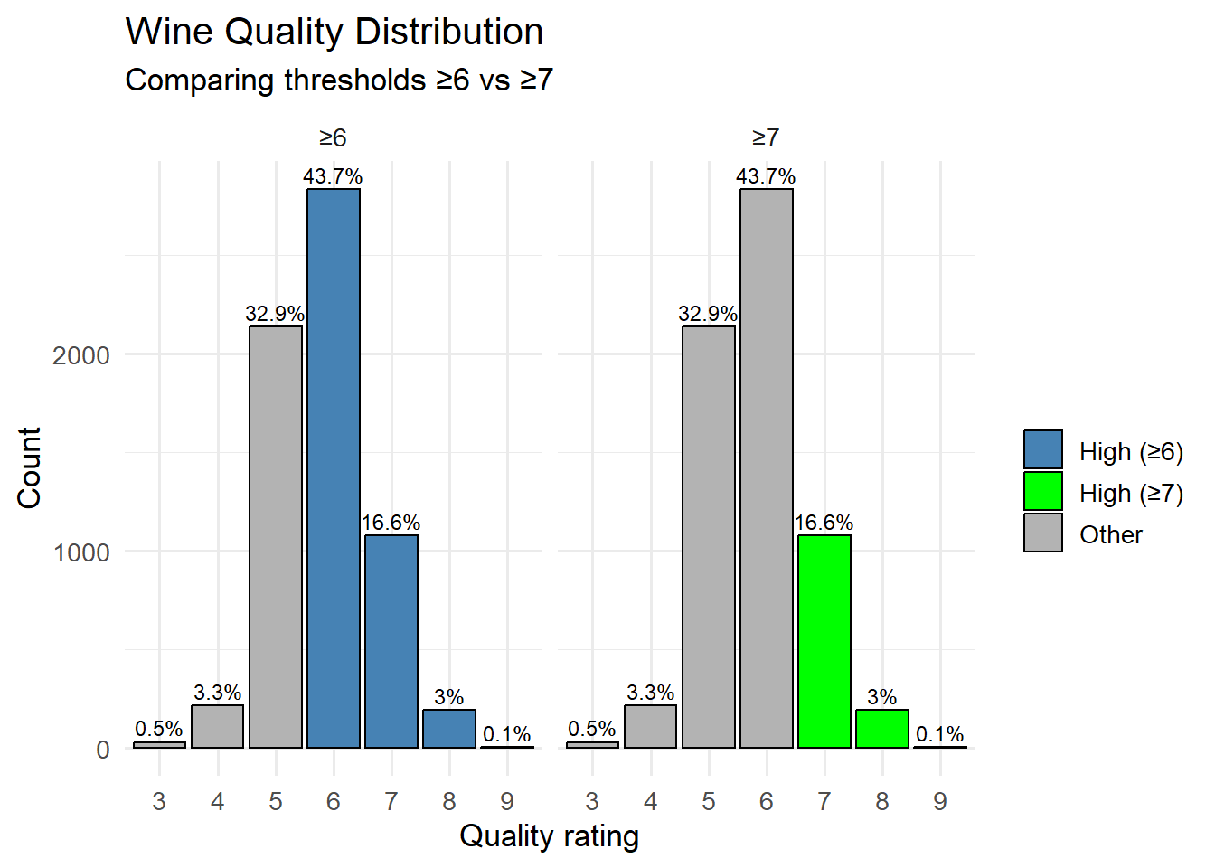
Fig. 8. Wine Quality Distribution: Comparing thresholds ≥6 vs ≥7
# Combine summaries for side-by-side table
quality_summary_all <- bind_rows(summary_6$summary, summary_7$summary)

kable(quality_summary_all, caption = "Table 4. Summary: Threshold Comparisons (≥6 vs ≥7)") %>%
kable_styling(full_width = FALSE, bootstrap_options = c("striped","hover"))
Table 4. Summary: Threshold Comparisons (≥6 vs ≥7)
threshold | group | Count | Percentage
≥6 | High (≥6) | 4113 | 63.3
≥6 | Other | 2384 | 36.7
≥7 | High (≥7) | 1277 | 19.7
≥7 | Other | 5220 | 80.3
We May See Improvemements With Rebinning Quality
When we first classified wines as high quality at a score of 6 or above, almost two-thirds of the wines (63.3%) landed in the high category. That means the “high” group was still full of average and good wines, not just the exceptional ones. By raising the bar to a score of 7 or above, the high category shrinks to just 19.7% of the wines — those that could truly be considered standouts — while the other 80.3% fall into the low group. This sharper separation might make it easier for the models to spot the difference between everyday wines and those that really rise above the rest.

Part 2, Task 2.2 Compare the Re-Binned Models
# =========================
# 5) Binary B: high = (quality ≥ 7) — SAME SPLIT
# =========================
train_B <- train_base %>% mutate(quality_label = factor(ifelse(quality >= 7, "high", "low"),
levels = c("low","high")))
test_B <- test_base %>% mutate(quality_label = factor(ifelse(quality >= 7, "high", "low"),
levels = c("low","high")))

results_B <- run_all_models_binary(train_B, test_B, base_features, "quality_label") %>%
mutate(Binning = "Binary: high ≥ 7")

# =========================
# 6) Combined comparison
# =========================
all_results <- bind_rows(results_A, results_B) %>%
relocate(Binning, Model) %>%
mutate(across(where(is.numeric), ~ round(.x, 4))) %>%
arrange(Binning, desc(Accuracy))

kable(all_results, caption = "Table 5. Two-Bin Comparisons (Same Train/Test Split Indices)") %>%
kable_styling(full_width = FALSE, bootstrap_options = c("striped","hover"))
Table 5. Two-Bin Comparisons (Same Train/Test Split Indices)
Binning | Model | Accuracy | Precision | Recall | F1 | AUC
Binary: high ≥ 6 | C5.0 | 0.7764 | 0.8310 | 0.8244 | 0.8277 | 0.8105
Binary: high ≥ 6 | CART | 0.7487 | 0.8000 | 0.8189 | 0.8093 | 0.7462
Binary: high ≥ 6 | Neural Network | 0.7467 | 0.7975 | 0.8189 | 0.8081 | 0.8098
Binary: high ≥ 6 | Logistic Regression | 0.7369 | 0.7870 | 0.8173 | 0.8019 | 0.8002
Binary: high ≥ 6 | Naive Bayes | 0.6918 | 0.7603 | 0.7693 | 0.7648 | 0.7593
Binary: high ≥ 7 | C5.0 | 0.8226 | 0.5510 | 0.4961 | 0.5221 | 0.7782
Binary: high ≥ 7 | CART | 0.8221 | 0.5746 | 0.3438 | 0.4302 | 0.6873
Binary: high ≥ 7 | Logistic Regression | 0.8164 | 0.5596 | 0.2835 | 0.3763 | 0.7994
Binary: high ≥ 7 | Neural Network | 0.8149 | 0.5490 | 0.2940 | 0.3829 | 0.7991
Binary: high ≥ 7 | Naive Bayes | 0.7513 | 0.4128 | 0.6457 | 0.5036 | 0.7600
Comparison of Rebinning Results
When wines were labeled as high quality at ≥6, 63.3% of the dataset qualified as high. This gave the models more balanced class sizes, leading to strong performance, especially with C5.0 (77.64% accuracy, 83.10% precision, 82.44% recall, 81.05% AUC).
When the threshold was raised to ≥7, only 19.7% of wines were labeled high quality. This created a more selective definition of “high,” effectively isolating only the very top performers. Accuracy in some models improved — C5.0 rose to 82.26% — but recall dropped significantly (49.61% for C5.0), meaning many high-quality wines were missed under the stricter definition.
Business Implication and Conclusion
A key lesson here is that improving model outcomes doesn’t always require hyperparameter tuning, ensemble methods, or more complex algorithms. Sometimes, redefining how the target variable is constructed — such as adjusting binning thresholds — can meaningfully shift performance. In this case, the stricter ≥7 threshold yielded higher accuracy but reduced the model’s ability to capture all high-quality wines. The choice between broader or stricter binning should be guided by the problem’s real-world objective: whether the priority is catching most of the good wines, or only the very best.

Appendix: Full code
Part 1
---
title: "IE 575 Final Exam"
author: "Eric Smith"
date: "2025-08-04"
output:
html_document:
css: styles.css
---

```{r setup, include=FALSE}
knitr::opts_chunk$set(
echo = TRUE,
warning = FALSE, # suppress warnings
message = FALSE # (optional) suppress package messages
)

setwd("D:/GradSchool/IE575/Final")
```

```{r load-libraries, include=FALSE}
library(tidyverse)
library(ggplot2)
library(ggthemes)
library(readxl)
library(dplyr)
library(caret)
library(pROC)
library(forecast)
library(tseries)
library(lubridate)
library(knitr)
library(tidyr)
library(zoo)
```

## Part 1, Task 1.1 Explore the Retail Dataset

```{r load-data}
# Load data
data <- read_excel("Online_Retail.xlsx")

head(data)
summary(data)

# Count missing values before removal
missing_values_before <- colSums(is.na(data))
print(missing_values_before)

# Remove rows with missing values
data <- na.omit(data)

```

```{r data-preprocessing}

# Remove rows with missing values -- For the sake of argument, we may only want to track our known customers
data <- na.omit(data)
# Check for duplicate values
duplicate_values <- data[duplicated(data), ]
if (nrow(duplicate_values) > 0) {
print("Count of duplicate values found:")
print(nrow(duplicate_values))
} else {
print("No duplicate values found.")
}
# Convert InvoiceDate to POSIXct
data$InvoiceDate <- as.POSIXct(data$InvoiceDate, format = "%Y-%m-%d %H:%M:%S")
```

```{r}

# === Extract date and time components ===
data$date_only <- as.Date(data$InvoiceDate)
data$hour_only <- hour(data$InvoiceDate)

# Optional: create a "total value" column for analysis
data <- data %>%
mutate(TotalValue = Quantity * UnitPrice)

# === How many days are in the dataset? ===
unique_days <- unique(data$date_only)
num_days <- length(unique_days)
cat("Number of unique days in dataset:", num_days, "\n")

# === How many records per day? ===
records_per_day <- table(data$date_only)
records_per_day_vec <- as.numeric(records_per_day)

# Summary statistics
cat("Summary of Records per Day:\n")
summary(records_per_day_vec)

records_df <- data.frame(Date = as.Date(names(records_per_day)), Count = as.numeric(records_per_day))

ggplot(records_df, aes(x = Count)) +
geom_histogram(binwidth = 50, fill = "steelblue", color = "white") +
labs(title = "Distribution of Records per Day", x = "Record Count", y = "Frequency") +
theme_minimal()

```
<center>Fig. 1: Distribution of Records per Day</center>

> **Data Exploration**
>
> The dataset (`Online_Retail.xlsx`) contained 541,909 transactions from Dec, 2010 to Dec. 2011 with eight variables. Summary showed extreme Quantity (min = -80,995, max = 80,995) and UnitPrice (min = -11,062.06, max = 38,970) values. Missing data checks found 1,454 missing Description entries and 135,080 missing CustomerID values. All 135,080 incomplete rows were removed via na.omit() supposing that we only wanted to analyze known customers. Duplicates were checked but not removed, and derived fields (date_only, hour_only, TotalValue) were created.
>
> Daily aggregation revealed 305 unique days, with transactions/day ranging from 221 to 3,434 (median = 1,186).
>
> **Key Observations:**
>
> - 135,080 rows removed due to missing customer ID values.
> - Quantity and UnitPrice show extreme outliers, likely returns or errors.
> - Noticable daily variation supports a time series formulation.

## Part 1, Task 1.2 Aggregate Daily Sales

```{r preprocessing}
data <- data %>%
mutate(date_only = as.Date(InvoiceDate),
TotalValue = Quantity * UnitPrice)

# Daily aggregation
daily_sales <- data %>%
group_by(date_only) %>%
summarise(Total_Sales = sum(TotalValue, na.rm = TRUE))

# Complete daily sequence
full_dates <- data.frame(date_only = seq(min(daily_sales$date_only), max(daily_sales$date_only), by = "day"))
daily_sales_complete <- full_dates %>%
left_join(daily_sales, by = "date_only") %>%
mutate(Total_Sales = replace_na(Total_Sales, 0))

# Cap at 99th percentile
threshold <- quantile(daily_sales_complete$Total_Sales, 0.99)
daily_sales_complete <- daily_sales_complete %>%
mutate(Capped_Sales = ifelse(Total_Sales > threshold, threshold, Total_Sales))
```

```{r smoothing-plot}
daily_sales_complete <- daily_sales_complete %>%
arrange(date_only) %>%
mutate(Smoothed_Sales = rollmean(Capped_Sales, k = 7, fill = NA, align = "right"))

ggplot(daily_sales_complete, aes(x = date_only, y = Smoothed_Sales)) +
geom_line(color = "steelblue", size = 1) +
labs(title = "7-Day Smoothed Capped Daily Sales",
x = "Date", y = "Sales (pounds) — 7-Day Avg") +
scale_x_date(date_labels = "%b %Y", date_breaks = "1 month") +
theme_minimal() +
theme(axis.text.x = element_text(angle = 45, hjust = 1))
```
<center>Fig. 2: 7-Day Smoothed Capped Daily Sales</center>

> **Aggregation Choice**
>
> Sales were aggregated to the daily level to capture short-term variability, looking at one premise that the business owner may want to anticipate expected daily sales, although this could be done for weekly sales. While weekly aggregation could smooth volatility, daily data may be valuable for exploring daily expectations. The 7-day smoothed series shows short-term rises and falls, with an overall upward movement through 2011.

## Part 1, Task 1.3 Raw Time Series Decomposition

```{r decomposition}
ts_raw <- ts(daily_sales_complete$Capped_Sales, frequency = 7)
decomp <- stl(ts_raw, s.window = "periodic")
plot(decomp)
```
<center>Fig. 3: STL Decomposition of Daily Sales</center>

```{r stationarity-test}
deseasonal <- seasadj(decomp)
sales_diff <- diff(deseasonal)
adf.test(sales_diff)
```

```{r acf-pacf}
par(mfrow=c(2,1))
acf(sales_diff, main = "ACF of Differenced Series")
pacf(sales_diff, main = "PACF of Differenced Series")
```
<center>Fig. 4: ACF and PACF of Differenced Series</center>

> **Decomposition, Stationarity, ACF an PACF**
>
> The decomposition reveals strong recurring weekly patterns, confirmed by the clear periodic spikes in the seasonal component. The trend shows a gradual increase in sales over time with short-term fluctuations, while the remainder is relatively small but irregular. The ACF and PACF plots show that the influence of past data drops sharply after just one lag. This is statistically supported by the Augmented Dickey-Fuller test (p-value = 0.01), telling us that the data is ready for ARIMA modeling.

## Part 1, Task 1.4 Outlier Detection and Replacement

```{r}

# --- Outlier detection & plotting (hardened against missing `types`) ---

y_ts <- ts_raw
out <- forecast::tsoutliers(y_ts) # $index, $replacements, (sometimes) $types

# Align dates safely to the series length
dates_ts <- tail(daily_sales_complete$date_only, length(y_ts))

# Always-initialized vectors
idx_all <- seq_along(y_ts)
is_out <- rep(FALSE, length(y_ts))
out_type <- rep(NA_character_, length(y_ts))

if (length(out$index) > 0) {
# If `types` is missing or length 0, create a generic label vector of same length as indices
types_safe <- if (!is.null(out$types) && length(out$types) == length(out$index)) {
out$types
} else {
rep("outlier", length(out$index))
}

is_out[out$index] <- TRUE
out_type[out$index] <- types_safe
}

df_out <- tibble(
idx = idx_all,
Date = dates_ts,
Value = as.numeric(y_ts),
is_out = is_out,
out_type = out_type
)

# Plot
p <- ggplot(df_out, aes(Date, Value)) +
geom_line(linewidth = 0.7, color = "steelblue") +
geom_point(data = dplyr::filter(df_out, is_out), color = "red", size = 2) +
labs(title = "Daily Sales with Detected Outliers Highlighted",
x = NULL, y = "Capped Sales (pounds)") +
theme_minimal()

# Optional labels (uses base geom_text to avoid extra deps)
if (any(is_out)) {
p <- p + geom_text(
data = dplyr::filter(df_out, is_out),
aes(label = out_type),
vjust = -0.8, size = 3
)
}
print(p)

```
<center>Fig. 5: Daily Sales with Detected Outliers Highlighted</center>

```{r outlier-replacement}

# Clean only flagged points
y_ts_clean <- y_ts
if (length(out$index) > 0) {
y_ts_clean[out$index] <- out$replacements
}

```

> **Detecting and Removing Outliers**
>
> The tsoutliers function detected 10 significant anomalies in the daily sales series, including both unusually high spikes and a zero-sales day. Each was flagged as an “outlier” and replaced with an estimated value based on the surrounding data to reduce distortion in model fitting. You can see the extreme values in the charting, and we'll be removing the outliers for our models.

# Part 1, Task 2.1 Creating ARIMA Models, Forecasting and Comparision

```{r model-fitting}
# Original series (with outliers still present)
y_ts_orig <- y_ts

# 1) Manual model on CLEANED series (deseasonalize via STL, then ARIMA(1,1,1) on seasadj)
decomp_clean <- stl(y_ts_clean, s.window = "periodic")
deseasonal_clean <- seasadj(decomp_clean)

model_manual_clean <- forecast::Arima(deseasonal_clean, order = c(1,1,1))

# Build a seasonal index to add back for h-step forecasts
# NOTE: this aligns the next h seasonal components to the day *after* the last observation.
h <- 10
freq <- frequency(y_ts_clean) # expected 7 for daily with weekly seasonality
seasonal_pattern <- tapply(decomp_clean$time.series[, "seasonal"], cycle(y_ts_clean), mean)
phase_next <- (cycle(y_ts_clean)[length(y_ts_clean)] %% freq) + 1
seasonal_future <- seasonal_pattern[((phase_next - 1) + 0:(h - 1)) %% freq + 1]

# 2) Auto models (original vs cleaned) for comparison
model_auto_orig <- forecast::auto.arima(y_ts_orig, stepwise = FALSE, approximation = FALSE)
model_auto_clean <- forecast::auto.arima(y_ts_clean, stepwise = FALSE, approximation = FALSE)
```

```{r diagnostics}
# --- Diagnostics ---

# Helper to get Ljung–Box p-value with a reasonable lag
.lb_pval <- function(model, lag_max = 15) {
r <- residuals(model)
n <- length(r)
lag <- min(lag_max, n - 1)
# fitdf: nonseasonal p+q + seasonal P+Q if available
fitdf <- tryCatch({
arma <- model$arma
if (length(arma) >= 4) sum(pmax(0, arma[c(1,2,3,4)])) else 0
}, error = function(e) 0)
tryCatch(Box.test(r, lag = lag, type = "Ljung-Box", fitdf = fitdf)$p.value,
error = function(e) NA_real_)
}

# Summarize ACF/PACF without plotting
.summarize_resid <- function(model, label, lag_max = 15) {
r <- as.numeric(residuals(model))
n <- length(r)
se <- 1 / sqrt(n)

acf_vals <- tryCatch(acf(r, plot = FALSE, lag.max = lag_max)$acf[-1], error = function(e) rep(NA_real_, lag_max))
pacf_vals <- tryCatch(pacf(r, plot = FALSE, lag.max = lag_max)$acf, error = function(e) rep(NA_real_, lag_max))

data.frame(
Model = label,
AICc = suppressWarnings(if (!is.null(model$aicc)) model$aicc else AIC(model)),
BIC = tryCatch(BIC(model), error = function(e) NA_real_),
ResidSD = sqrt(model$sigma2),
LB_p = .lb_pval(model, lag_max = lag_max),
MaxAbsACF = max(abs(acf_vals), na.rm = TRUE),
MaxAbsPACF = max(abs(pacf_vals), na.rm = TRUE),
SigACF_Count = sum(abs(acf_vals) > 1.96 * se, na.rm = TRUE),
SigPACF_Count = sum(abs(pacf_vals) > 1.96 * se, na.rm = TRUE),
check.names = FALSE
)
}

diag_table <- bind_rows(
.summarize_resid(model_manual_clean, "Manual ARIMA (Cleaned, deseasonal)", lag_max = 15),
.summarize_resid(model_auto_orig, "Auto ARIMA (Original)", lag_max = 15),
.summarize_resid(model_auto_clean, "Auto ARIMA (Cleaned)", lag_max = 15)
) %>%
mutate(
across(c(AICc, BIC, ResidSD, LB_p, MaxAbsACF, MaxAbsPACF), ~round(., 3))
)

kable(diag_table, caption = "Table 1. Residual Diagnostics (ACF/PACF & Ljung–Box, lag ≤ 15)")

```
> **Model Diagnostics**
>
> Cleaning the series before fitting improved both model fit and residual diagnostics for the automatic and manual ARIMA models. The cleaned Auto ARIMA performed best, with the lowest AICc and BIC, smallest residual variance, and no significant autocorrelation—indicating it captured the time series structure well. The manual ARIMA left notable residual autocorrelation, suggesting it underfit the data.
```{r forecast-plot}
# --- Forecasts & plots (original vs cleaned) ---

# Manual (cleaned): forecast deseasonalized model, then add seasonality back
fc_manual_deseason <- forecast::forecast(model_manual_clean, h = h)
fc_manual_clean <- fc_manual_deseason
fc_manual_clean$mean <- fc_manual_deseason$mean + seasonal_future
fc_manual_clean$lower <- fc_manual_deseason$lower + matrix(seasonal_future, nrow = h, ncol = ncol(fc_manual_deseason$lower), byrow = FALSE)
fc_manual_clean$upper <- fc_manual_deseason$upper + matrix(seasonal_future, nrow = h, ncol = ncol(fc_manual_deseason$upper), byrow = FALSE)

# Auto (original vs cleaned)
fc_auto_orig <- forecast::forecast(model_auto_orig, h = h)
fc_auto_clean <- forecast::forecast(model_auto_clean, h = h)

# Plots stacked vertically with compact height
par(mfrow = c(3, 1), # 3 rows, 1 column
mar = c(3, 4, 3, 2)) # smaller margins: bottom, left, top, right

plot(fc_manual_clean, main = "Manual ARIMA Forecast on CLEANED Series (seasonality added back)")
plot(fc_auto_orig, main = "Auto ARIMA Forecast (ORIGINAL series)")
plot(fc_auto_clean, main = "Auto ARIMA Forecast (CLEANED series)")
par(mfrow = c(1, 1)) # reset layout

```

<center>Fig. 6: Forecasts from Different ARIMA Models</center>

```{r}

# --- 2.2 Forecast comparison (manual-clean vs auto-clean) ---
forecast_dates <- seq(max(daily_sales_complete$date_only) + 1, by = "day", length.out = h)

df_auto_clean <- data.frame(
Date = forecast_dates,
Forecast = as.numeric(fc_auto_clean$mean),
Lower = as.numeric(fc_auto_clean$lower[, 2]),
Upper = as.numeric(fc_auto_clean$upper[, 2]),
Model = "Auto ARIMA (Cleaned)"
)

df_manual_clean <- data.frame(
Date = forecast_dates,
Forecast = as.numeric(fc_manual_clean$mean),
Lower = as.numeric(fc_manual_clean$lower[, 2]),
Upper = as.numeric(fc_manual_clean$upper[, 2]),
Model = "Manual ARIMA (Cleaned, deseasonal->reseas.)"
)

combined_forecasts_clean <- dplyr::bind_rows(df_auto_clean, df_manual_clean)

ggplot(combined_forecasts_clean, aes(x = Date, y = Forecast, color = Model, fill = Model)) +
geom_line(size = 1.2) +
geom_ribbon(aes(ymin = Lower, ymax = Upper), alpha = 0.2, color = NA) +
labs(
title = "10-Day Forecasts on CLEANED Series: Manual vs Auto",
x = "Date", y = "Predicted Daily Sales (pounds)"
) +
theme_minimal()

```
<center>Fig. 7: 10-Day Forecasts on CLEANED Series: Manual vs Auto</center>

```{r compare-metrics}
get_train_metrics <- function(fc, label) {
m <- as.data.frame(forecast::accuracy(fc))
m <- m[1, , drop = FALSE] # row 1 = in-sample (training) metrics
m$Model <- label
m
}

fcs <- list()
if (exists("fc_auto_orig")) fcs[["Auto ARIMA (Original)"]] <- fc_auto_orig
if (exists("fc_auto_clean")) fcs[["Auto ARIMA (Outliers Removed)"]] <- fc_auto_clean
if (exists("fc_manual_clean")) fcs[["Manual ARIMA (Outliers Removed)"]] <- fc_manual_clean

if (length(fcs) == 0) {
stop("No forecast objects found. Ensure the forecast chunk ran.")
}

comparison <- do.call(
rbind,
lapply(names(fcs), function(lbl) get_train_metrics(fcs[[lbl]], lbl))
) %>%
select(Model, ME, RMSE, MAE, MASE)

kable(comparison, caption = "Table 2. Model Comparison (Training Set)")
```

> **Model Comparison**
>
> We tested two different ARIMA approaches on the cleaned, seasonally adjusted sales data — a manually set ARIMA(1,1,1) model and an Auto ARIMA that picks parameters automatically. Both were also tested after removing outliers to see if that improved performance.
>
> The Auto ARIMA applied to the original, uncleaned data had the weakest results, with an RMSE of about 10,195 and an MAE of 7,401. Once we removed outliers, the Auto ARIMA improved noticeably, dropping RMSE to 8,870 and MAE to 6,516. That’s a significant gain in accuracy, showing the value of cleaning the data before modeling.
>
> The manually chosen ARIMA(1,1,1), run on the cleaned data, had an RMSE of 9,398 and an MAE of 7,258 — not as strong as the tuned Auto ARIMA, but still better than the Auto ARIMA run on the uncleaned series. This makes it a useful baseline for understanding how parameter choices affect performance.
>
> Looking at the average forecast error (ME), all three models stayed close to zero compared to the overall sales scale. The Auto ARIMA runs tended to slightly overpredict (+251 for the uncleaned data and +186 for the cleaned data), while the manual ARIMA slightly underpredicted (–38). These biases are small enough that they wouldn’t cause big issues in day-to-day decision-making.
>
> **Conclusion:**
>
> Cleaning the data and letting Auto ARIMA tune the parameters gave the best accuracy and the most reliable forecasts. For a business, that means a clearer picture of demand — making it easier to plan inventory, staff schedules, and promotions with confidence. The manual ARIMA still has value as a simple benchmark, but the automated approach shows how parameter tuning and outlier handling can deliver real gains.
Part 2
---
output:
html_document:
css: styles.css
---

```{r setup, include=FALSE}
knitr::opts_chunk$set(
echo = TRUE,
warning = FALSE, # suppress warnings
message = FALSE # (optional) suppress package messages
)

setwd("D:/GradSchool/IE575/Final")
```

```{r, include=FALSE}
# --- Libraries ---
suppressPackageStartupMessages({
library(tidyverse)
library(caret)
library(pROC)
library(C50)
library(rpart)
library(nnet) # nnet()
library(e1071) # naiveBayes()
library(kableExtra)
library(knitr)
library(ggplot2)
})
```

## Part 2, Task 1.1 Explore the Wine Quality Dataset

```{r}

# =========================
# Load
# =========================
winedata <- read.csv("Q2_winequality.csv")

# Structure (compact) + NA & duplicates
glimpse(winedata)
missing_vals <- colSums(is.na(winedata))
dup_rows <- sum(duplicated(winedata))
cat("\nMissing values by column:\n"); print(missing_vals)
cat("\nDuplicate row count:", dup_rows, "\n")
```

> **Exploring the Wine Quality Dataset**
>
> The dataset contains 6,497 wine samples, each with 13 attributes describing chemical composition, wine type (red or white), and a quality rating on a 0–10 scale. All variables are complete — no missing values were found in any column. There are 1,177 duplicate rows, likely representing multiple measurements of identical wine characteristics, which is reasonable given the nature of wine production. Since the data is already well-structured and clean, no significant preprocessing was required before modeling.

## Part 2, Task 1.2 Create Five Classification Models

```{r}

# Set test and training data objects
set.seed(123)
idx_train <- sample(seq_len(nrow(winedata)), size = floor(0.7 * nrow(winedata)))
idx_test <- setdiff(seq_len(nrow(winedata)), idx_train)
train_base <- winedata[idx_train, ]
test_base <- winedata[idx_test, ]

# Predictors: everything except label-ish fields and raw 'quality'
base_features <- setdiff(names(winedata),
c("quality","quality_label","quality_label_b",
"quality_3class","winetype"))

# =========================
# 2) Helpers (binary metrics + model runner)
# =========================
get_metrics <- function(prob, pred_class, actual, model_name) {
pred_class <- factor(pred_class, levels = levels(actual))
cm <- confusionMatrix(pred_class, actual, positive = "high")
roc_obj <- tryCatch(roc(actual, as.numeric(prob), levels = c("low","high")),
error = function(e) NA)
auc_val <- if (is.list(roc_obj)) as.numeric(auc(roc_obj)) else NA_real_
tibble(
Model = model_name,
Accuracy = as.numeric(cm$overall[["Accuracy"]]),
Precision = as.numeric(cm$byClass[["Precision"]]),
Recall = as.numeric(cm$byClass[["Recall"]]),
F1 = as.numeric(cm$byClass[["F1"]]),
AUC = auc_val
)
}

run_all_models_binary <- function(train, test, features, label_col = "quality_label") {
form <- as.formula(paste(label_col, "~", paste(features, collapse = " + ")))

# Logistic
log_model <- glm(form, data = train, family = "binomial")
log_prob <- predict(log_model, test, type = "response")
log_class <- ifelse(log_prob > 0.5, "high", "low")

# CART
cart_model <- rpart(form, data = train)
cart_prob <- predict(cart_model, test, type = "prob")[, "high"]
cart_pred <- predict(cart_model, test, type = "class")

# C5.0
c50_model <- C5.0(form, data = train)
c50_prob <- predict(c50_model, test, type = "prob")[, "high"]
c50_pred <- predict(c50_model, test)

# Neural Net
nn_model <- nnet(form, data = train, size = 5, maxit = 200, trace = FALSE)
nn_raw <- predict(nn_model, test, type = "raw")
nn_prob <- if (is.matrix(nn_raw)) {
if (!is.null(colnames(nn_raw)) && "high" %in% colnames(nn_raw)) {
nn_raw[, "high", drop = TRUE]
} else if (ncol(nn_raw) == 2) {
levs <- levels(test[[label_col]])
nn_raw[, which(levs == "high"), drop = TRUE]
} else as.numeric(nn_raw)
} else as.numeric(nn_raw)
nn_class <- ifelse(nn_prob > 0.5, "high", "low")

# Naive Bayes
nb_model <- naiveBayes(form, data = train)
nb_prob <- predict(nb_model, test, type = "raw")[, "high"]
nb_pred <- predict(nb_model, test)

bind_rows(
get_metrics(log_prob, log_class, test[[label_col]], "Logistic Regression"),
get_metrics(cart_prob, cart_pred, test[[label_col]], "CART"),
get_metrics(c50_prob, c50_pred, test[[label_col]], "C5.0"),
get_metrics(nn_prob, nn_class, test[[label_col]], "Neural Network"),
get_metrics(nb_prob, nb_pred, test[[label_col]], "Naive Bayes")
)
}

# =========================
# 3) Binary A: high = (quality ≥ 6)
# =========================
train_A <- train_base %>% mutate(quality_label = factor(ifelse(quality >= 6, "high", "low"),
levels = c("low","high")))
test_A <- test_base %>% mutate(quality_label = factor(ifelse(quality >= 6, "high", "low"),
levels = c("low","high")))

results_A <- run_all_models_binary(train_A, test_A, base_features, "quality_label") %>%
mutate(Binning = "Binary: high ≥ 6")

kable(results_A %>% mutate(across(where(is.numeric), ~ round(.x, 4))),
caption = "Table 3. Performance with Binary Label: high ≥ 6") %>%
kable_styling(full_width = FALSE, bootstrap_options = c("striped","hover"))

```

> **Initial Modeling with Binary Threshold ≥ 6**
>
> For the first round of modeling, wines were labeled as high quality if their rating was 6 or greater, and low otherwise. Using a fixed 70/30 train/test split across all models, the C5.0 decision tree performed best, achieving 77.6% accuracy, 0.831 precision, and 0.8277 F1 score, with an AUC of 0.8105. CART and the Neural Network performed similarly, each with recall above 0.81, while Logistic Regression delivered slightly lower accuracy at 73.7%. Naïve Bayes lagged behind, with 69.2% accuracy and lower AUC. While several models achieved reasonable balance between precision and recall, the overall accuracy remained below 80%, suggesting room for improvement by adjusting how we define high quality. This led us to examine the quality rating distribution more closely to determine if a stricter threshold might yield better predictive performance.

## Part 2, Task 2.1 Explore How to Improve Model Using Dataset

```{r}

# =========================
# 4) Quality distribution (to motivate ≥7)
# =========================
# =========================
# Side-by-side distribution for ≥6 and ≥7
# =========================

make_quality_summary <- function(data, threshold) {
label <- paste0("High (≥", threshold, ")")
dist <- data %>%
count(quality) %>%
mutate(
perc = round(100 * n / sum(n), 1),
group = ifelse(quality >= threshold, label, "Other"),
threshold = paste0("≥", threshold)
)

summary <- dist %>%
group_by(threshold, group) %>%
summarise(Count = sum(n), .groups = "drop") %>%
mutate(Percentage = round(100 * Count / sum(Count), 1))

list(dist = dist, summary = summary)
}

# Make both sets
summary_6 <- make_quality_summary(winedata, 6)
summary_7 <- make_quality_summary(winedata, 7)

# Combine distributions for plotting
quality_dist_all <- bind_rows(summary_6$dist, summary_7$dist)

# Plot side-by-side facets
ggplot(quality_dist_all, aes(x = factor(quality), y = n, fill = group)) +
geom_col(color = "black") +
geom_text(aes(label = paste0(perc, "%")), vjust = -0.4, size = 3.2) +
scale_fill_manual(values = c("Other" = "gray70",
"High (≥6)" = "steelblue",
"High (≥7)" = "green")) +
labs(
title = "Wine Quality Distribution",
subtitle = "Comparing thresholds ≥6 vs ≥7",
x = "Quality rating", y = "Count", fill = ""
) +
facet_wrap(~ threshold, ncol = 2) +
theme_minimal(base_size = 13)

```

<center>Fig. 8. Wine Quality Distribution: Comparing thresholds ≥6 vs ≥7</center>

```{r}

# Combine summaries for side-by-side table
quality_summary_all <- bind_rows(summary_6$summary, summary_7$summary)

kable(quality_summary_all, caption = "Table 4. Summary: Threshold Comparisons (≥6 vs ≥7)") %>%
kable_styling(full_width = FALSE, bootstrap_options = c("striped","hover"))

```

> ** We May See Improvemements With Rebinning Quality**
>
> When we first classified wines as high quality at a score of 6 or above, almost two-thirds of the wines (63.3%) landed in the high category. That means the “high” group was still full of average and good wines, not just the exceptional ones. By raising the bar to a score of 7 or above, the high category shrinks to just 19.7% of the wines — those that could truly be considered standouts — while the other 80.3% fall into the low group. This sharper separation might make it easier for the models to spot the difference between everyday wines and those that really rise above the rest.

## Part 2, Task 2.2 Compare the Re-Binned Models

```{r}

# =========================
# 5) Binary B: high = (quality ≥ 7) — SAME SPLIT
# =========================
train_B <- train_base %>% mutate(quality_label = factor(ifelse(quality >= 7, "high", "low"),
levels = c("low","high")))
test_B <- test_base %>% mutate(quality_label = factor(ifelse(quality >= 7, "high", "low"),
levels = c("low","high")))

results_B <- run_all_models_binary(train_B, test_B, base_features, "quality_label") %>%
mutate(Binning = "Binary: high ≥ 7")

# =========================
# 6) Combined comparison
# =========================
all_results <- bind_rows(results_A, results_B) %>%
relocate(Binning, Model) %>%
mutate(across(where(is.numeric), ~ round(.x, 4))) %>%
arrange(Binning, desc(Accuracy))

kable(all_results, caption = "Table 5. Two-Bin Comparisons (Same Train/Test Split Indices)") %>%
kable_styling(full_width = FALSE, bootstrap_options = c("striped","hover"))

```

> **Comparison of Rebinning Results**
>
> When wines were labeled as high quality at ≥6, 63.3% of the dataset qualified as high. This gave the models more balanced class sizes, leading to strong performance, especially with C5.0 (77.64% accuracy, 83.10% precision, 82.44% recall, 81.05% AUC).
>
> When the threshold was raised to ≥7, only 19.7% of wines were labeled high quality. This created a more selective definition of “high,” effectively isolating only the very top performers. Accuracy in some models improved — C5.0 rose to 82.26% — but recall dropped significantly (49.61% for C5.0), meaning many high-quality wines were missed under the stricter definition.
>
> **Business Implication and Conclusion**
>
> A key lesson here is that improving model outcomes doesn’t always require hyperparameter tuning, ensemble methods, or more complex algorithms. Sometimes, redefining how the target variable is constructed — such as adjusting binning thresholds — can meaningfully shift performance. In this case, the stricter ≥7 threshold yielded higher accuracy but reduced the model’s ability to capture all high-quality wines. The choice between broader or stricter binning should be guided by the problem’s real-world objective: whether the priority is catching most of the good wines, or only the very best.

